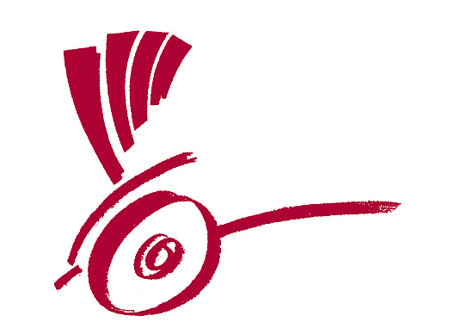

Project holder Questionair - Calcutta Rescue Germany e.V.

Application for granting financial support

Calcutta Rescue Deutschland e.V.
Mittermayrstr. 12
80796 München
Germany

Phone no.: +498005890489

IBAN DE04 7015 0000 0000 1355 09
BIC (S.W.I.F.T.) SSKMDEMM

county court: Vereinsregister VR 12757 des Amtsgerichtes in München
common public interest: Anerkannt durch das Finanzamt München unter 143/212/00045
President: Charlotte Lübow
Manager: Stefanie Weißig
Treasurer: Stefan Huth

info@calcuttarescue.de
www.calcutta-rescue.de

1.
  Basic data on the project holder
  Name of the organisation:
  Name of directors/general secretary:
  Board of directors:
  Postal address:
  Office address:
  Contact person:
  Account relationship:
1.1
  Has the organisation got any branch offices/subsidiaries in addition to the above mentioned address (regional, local)? If yes, provide details.
2.
  Organisational structure and working methods of the project holder
  Information on the legal status (foundation year, legal form) and on the charitable status. Please attach a copy of the certificate of registration (confirmation) and an up-dated version of your organisation’s statutes. (By-laws, Constitution, etc.)
  enclosed yes no
2.1
  Describe briefly the origin, development and basic funding of the organisation.
2.2
  Outline the authority and competencies at the supervisory level (e.g. Board of Directors /Trustees etc.) and at the implementation level (Executive Director, Management Board etc.).
2.3
  Members of the supervisory body (e.g. Board of Directors / Trustees etc.): Name, sex, function, social representation (if they represent any social/religious group, the target group etc.)
  Name: | Sex: | Function: | Social representation:
2.4
  Submit an organigram (organisational chart) of the organisation.
  enclosed yes no
2.5
  Information on the staff: Name, sex, function, qualification, since when with the organisation, percent of a full-time position.(In the case of big organisations it is sufficient to provide information on the staff supposed to work with the project presented to Calcutta Rescue (Germany) e.V. only.)
  Name: | Sex: | Function: | Qualification: | Since when with the organisation: | Percent of a full-time position:
2.6
  Describe briefly the individual functional units (administration, programme units etc.)
2.7
  Describe briefly whether and in which way the staff and the target group/ beneficiaries are usually involved in the decision-making processes in the organisation.
2.8
  Outline briefly the standard procedures in the organisation and particularly the regulations for financial management.
2.9
  Was an financial audit carried out for the organisation in the last financial year? If so, please provide Calcutta Rescue (Germany) e.V. with a copy.
  enclosed yes no
3.
  Policies of the organisation
  What visions does the organisation pursue? What are the goals aimed at?
3.1
  Has the organisation a written gender policy? If yes, please provide a copy. If not, please describe briefly your ideas and practice about gender.
  enclosed yes no-
4.
  Areas of work (sectorial, regional)
  In which sectors is the organisation actively involved? Which of these are core project components? Which of these are of less priority?
4.1
  In which regions of the country is the organisation working? Please attach a map of the country and possibly a map of the region/province and mark the respective regions/areas.
  enclosed yes no
5.
  Cooperation in terms of content and finances
  For church-related project holders:
  Describe briefly whether and what kind of local, national and/or international ecumenical cooperation relationships are in existence.
5.1
  For NGOs/community based organisations/networks:
  Outline the organisation’s relationships to local, national and/or international church and ecumenical institutions.
5.2
  With which (national and international) aid agencies and financing organisations has the organisation been cooperating in the past five years?
5.3
  With which (national and international) aid agencies and financing organisations does the organisation presently cooperate? Please give the following information: Name of agency, title of project, funding phase, total budget, amount of funding support.
  Name of agency | Title of project | Funding phase | Total budget | Amount of funding support
5.4
  To which (national and international) aid agencies and financing organisations have project proposals been submitted recently? What is the status of these proposals?
6.
  Signature and Date

